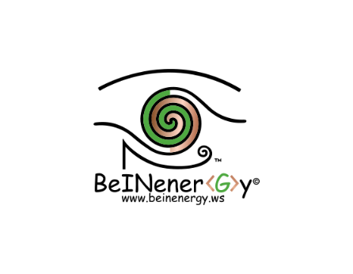

Please fill out this form and send it to [Naomi@beinenergy.ws](mailto:Naomi@beinenergy.ws)

Initial Client Enquiry Process Step 1.

Name: Email Address:

Company: Contact Details:

Date: Website:

Location: Preferred time/way to contact you?

Where did you hear of BeINenerGy?

What Services are you interested in? New Business Vision, Brainstorming, Coaching, Information, Advice and Guidance, Project Administration, other?

There is no fee for the 1st consultation, however you can offer a free will offering based on the value you have put on this consultation to <https://www.paypal.me/BeINenerGy>. I understand that not everyone has capital to pay specific upfront fees upon initial contact; I value your need to see if BeINenerGy is the right organisation to work with you moving forward. I am sure that you will find the initial consultation a positive and productive experience.

I look forward to hearing from you.

Office Use Only: Client Consultation: Y/N Assessed Client’s Needs: Y/N Terms of Service Agreed: Y/N

Notes:

Date and Time of Consultation: Location. Client File Number:

What is it that you would like BeINenerGy to help you with? (This could be your idea or your issues that you are having? Based on the services you are enquiring about)

Tell me a little bit about yourself? (This could be you, and/or your company, and/or the work that you do?)